Boat Length | Monthly | Standard Use  Quarterly | Annually | Monthly | Higher Use  Quarterly | Annually
Up to 15m  Up to 50ft | £250 | £715 | £2645 | £310 | £880 | £3250
15m-16m  (50ft-53ft) | £270 | £760 | £2815 | £340 | £920 | £3435
16m-17m  (53ft-56ft) | £295 | £805 | £2995 | £350 | £975 | £3615
17m-18m  (56ft-60ft) | £305 | £865 | £3165 | £365 | £1035 | £3810
18m-19m  (60ft-63ft) | £325 | £905 | £3340 | £380 | £1080 | £3980
19m-20m  (63ft-66ft) | £340 | £950 | £3525 | £395 | £1125 | £4165
20m & above  (66ft +) | £355 | £985 | £3690 | £420 | £1170 | £4350
Mooring rates for Droitwich Spa Marina – All rates INCLUSIVE of VAT at 20% 1st Sept 2025

A deposit fee of £199 is required by all moorers, together with a completed booking form. This deposit reserves a mooring for up to 3 months, unless otherwise agreed. The deposit will be refunded on termination of the mooring and in accordance with our terms and conditions. If a reservation is cancelled before the mooring has commenced, the deposit is non-refundable. Moorings are payable on arrival. These prices apply on arrival to your mooring.

Shared Ownership Boats incur an initial administration charge fee of £200.
Visiting boats will be charged at £25 per night to include use of facilities and electric. Longer stays will be given a price upon application.
Electricity cards, pump out and laundry tokens are available to purchase from the office. Electricity is supplied with a prepayment card system in accordance with OFGEM regulations.
End or island Jetties will cost an additional £200 per annum paid in advance.

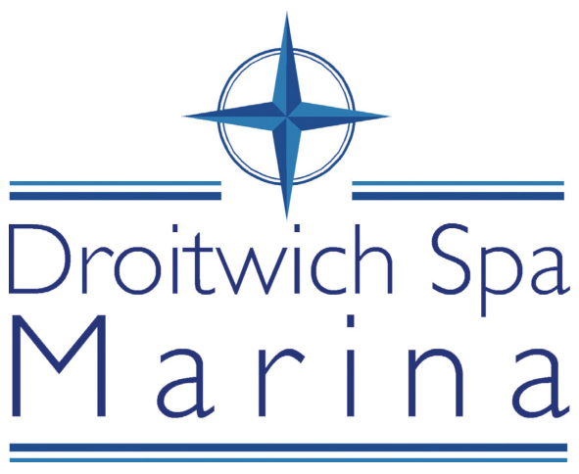
www.droitwichspamarina.co.uk

Mooring Tariffs

1st September 2025

The mooring rates are based on the length of boat, rather than the length of the jetty.

Tariffs have been designed to give boat owners as many options as possible. Payment options include annual, quarterly, and monthly.

Moorings include water, parking and use of all our luxury facilities.

Mooring Definitions
Standard use | This option is available for boaters who use their boat at any time and spend less than 4 nights a week on average on their boat.  Longer occasional stays are permitted.
Higher use | This option is available for boaters who spend 4 nights per week or more on the boat in the marina.  We permit unlimited leisure use of the mooring  The vessel is expected to leave the berth for refuelling, pumpout and cruising.
Hard Standing | This option is available for clients to have their boat out on hard standing for a limited period of time to carry out works i.e. painting and welding

Fees are due in advance. Payments can be made by standing order, cheque or BACS. Reservation fees can also be paid by credit or debit card. Late payments will incur a £30 per month admin fee. Please make cheques payable to Droitwich Spa Marina Ltd.

Monthly payments – two monthly payments are due on the first payment date followed by 10 monthly payments.

Annual and quarterly payments are only applicable if paid by the due date, otherwise the monthly rate will apply as well as the late payment admin fee per month.

Three months’ notice is required to terminate a contract. In the event of a refund, the invoice will be re-calculated at the quarterly rate up to the date of termination.

Slipway and cranage charges - price on application. The Droitwich Canal is a narrow beam canal, but please contact us if you would like to crane a wide berth vessel into the marina.

Prices are subject to change.

